Item | Company | Link (If available)
Apple Juice | High House | https://high-house.co.uk/
Artwork | At the cherry tree | https://atthecherrytree.co.uk/
Beef | Cratfield Beef
Beer | Adnams | https://adnams.co.uk/
Bread | Stradbroke Bakery | http://www.stradbrokebakery.co.uk/
Cheese | Fen Farm | https://fenfarmdairy.co.uk/
Chocolate | Gnaw | https://www.gnawchocolate.co.uk/
Cordials | Homemade
Eggs | Low Farm Huntingfield | https://www.lowfarmeggs.co.uk/
Firegrills | Roadii | https://roadii.co.uk/
Fish | Darrens | https://www.framlingham.com/darrens-fresh-fish
Gin | Fishers | https://fishersgin.com/
Ice Cream | Suffolk Meadow | https://www.suffolkmeadow.co.uk/
Ice Lollies | Lickety Ice | http://licketyice.co.uk/
Marshmallows & Drinking Vinegar | Yaffle House | https://www.yafflehouse.co.uk/
Meat | Hall Farm Butchery | https://www.hallfarmbutchers.co.uk/
Oil | Hill Farm | https://hillfarmoils.com/
Picnic Benches | Suffolk Picnic Benches | https://www.suffolkpicnicbenches.com/
Sauces | Stokes | https://www.stokessauces.co.uk/
Sausages & Turkey | P A Mobbs & Sons | https://pamobbs.co.uk/
Sausages, Bacon & Charcuterie | Lane Farm | https://www.lanefarm.co.uk/
Tea & Coffee | Freshpac Halesworth | https://freshpac.co.uk/
Veg (not available from our own garden) | Carl’s Veg | https://www.framlingham.com/carls-fruit-and-veg
Wine | DJ Wines | https://www.djwines.co.uk/our-products
Wood | Protimber | https://www.protimber.uk.com/
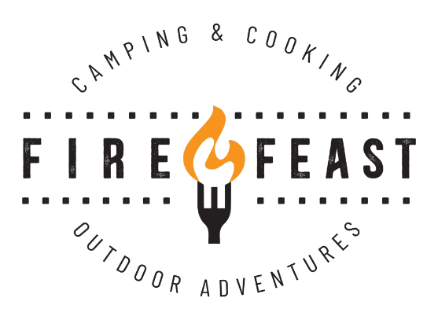

Local companies we use at Fire & Feast

